Che Yourself!
Load Pixlr from www.pixlr.com and select the advanced editor. Create a new image.
Find the Che Guevara picture from the ‘Che Yourself’ page on www.computinglesson.com
Save it to ‘My Pictures’ and then load it into Pixlr.
Cropping
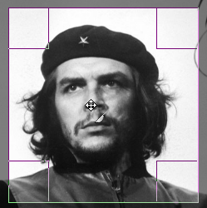
Crop the image using the crop tool to create a heroic profile. Mark a rectangle with the crop tool and double click to select. Now you have a smaller, more focused area to work on.
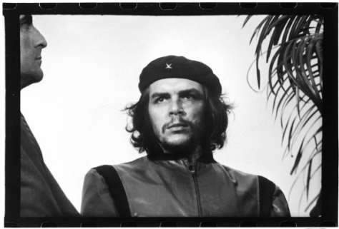

Use the eraser and magic wand tool to remove all of the background.
Changing the Colour
From the main menu, select ‘Adjustment’ and ‘Threshold’. Move the slider to get the best effect.
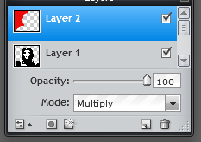
Click here to add a layer
Filling in the Background with Colour
Find the Layers window (if you can’t see it, choose ‘View’ and ‘Layers’)
Click here and Change the layer mode to ‘Multiply’

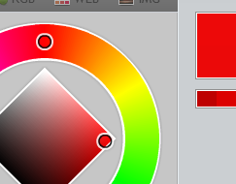
Colour
Click to set foreground colour
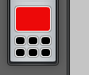
Now use the paintbrush.
Set the foreground colour
to red

Use the Paintbrush and Paint in the background.
E-mail the result to: gmacleod@mtsn.org.uk

