What does this programme do?
INP
STA FIRST
INP
ADD FIRST
OUT
HLT
FIRST DAT

Mnemonic | Instruction | Description | Opcode | Memory Location
INP
STA FIRST
INP
ADD FIRST
OUT
HLT
FIRST DAT

Now enter the code, compile it and check your answers.

Stepping through the code
Copy out the messages for each stage of this programme

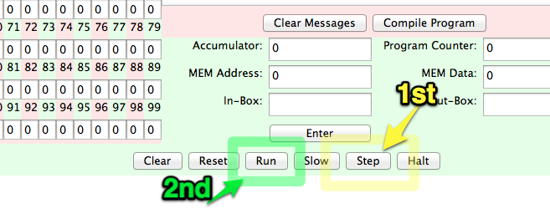
Mnemonic | Messages
INP
STA FIRST
INP
ADD FIRST
OUT
HLT
FIRST DAT

